“Skin Lesion Classification using Deep Learning”
PROJECT REPORT

Submitted by
Nitin Kumar Singh
60511503124

ABSTRACT

Skin cancer is one of the most common and potentially life-threatening diseases worldwide, and early detection plays a crucial role in improving patient survival rates. Traditional diagnostic methods rely heavily on dermatologists’ expertise, which can be time-consuming and subject to variability. With advancements in Artificial Intelligence (AI) and Deep Learning, automated systems have emerged as effective tools for medical image analysis.
This project presents an AI-based skin cancer classification system using Convolutional Neural Networks (CNN) with MobileNetV2 as the base model. The system is trained on the HAM10000 dataset, which consists of more than 10,000 dermoscopic images categorized into seven different classes of skin diseases. Various preprocessing techniques such as image resizing, normalization, and data augmentation are applied to improve data quality and handle class imbalance.
Transfer learning is employed to utilize pre-trained knowledge from large-scale datasets, and fine-tuning is performed to enhance model performance for domain-specific features. The model is trained and evaluated using accuracy and loss metrics, demonstrating effective classification capability and good generalization on unseen data.
The results show that the proposed system achieves satisfactory accuracy and can efficiently classify skin lesions into different categories. The system also provides a confidence score along with predictions, making it useful as a decision-support tool for medical professionals.
Overall, this project highlights the potential of deep learning in healthcare applications and demonstrates how AI can assist in early detection, reduce diagnostic effort, and improve the accuracy of skin cancer classification.

TABLE OF CONTENT

Certificate ii
Declaration iii
Acknowledgement iv
Abstract v
List of Tables viii
List of Figures ix
Chapter 1: Introduction 1
Chapter 2: Problem Statement 3
2.1: Problem Definition
2.2: Objectives
Chapter 3: Literature Review 5
Chapter 4: Research Methodology 10
4.1: Methodology Framework
4.2: Data Collection
4.3: Tools and Technologies Used
4.4: System Components
4.5: Model Architecture
4.6: Data Flow Representation
Chapter 5: Analysis and Research Implementation 17
5.1: Data Presentation
5.1.1: Class Distribution Analysis
5.1.2: Distribution Based on Body Part
5.1.3: Age Distribution Analysis
5.1.4: Summary of Data Insights
5.2: Implementation of the Work
5.2.1: Data Preprocessing
5.2.2: Model Development
5.2.3: Transfer Learning and Fine-Tuning
5.2.4: Model Training
5.2.5: Prediction and Output
5.3: Analysis and Interpretation
Chapter 6: Results and Discussion 25
6.1: Results
6.2: Discussion
6.3: Findings
Chapter 7: Summary and Conclusion 28
Chapter 8: Limitation of the Project and Future Work 29
Bibliography 30

LIST OF TABLES

Table 4.1: Tools and Technologies Used
Table 4.2: Description of System Components
Table 5.1: Skin Disease Classes in HAM10000 Dataset
Table 5.2: Training Parameters
Table 5.3: Model Performance Before and After Fine-Tuning
Table 6.1: Model Performance Metrics

LIST OF FIGURES

Fig 1.1: Skin Cancer Classification Process
Fig 4.1: Dataset Description
Fig 4.2: System Architecture of Skin Cancer Classification
Fig 4.3: Data Preprocessing Pipeline
Fig 4.4: Flowchart of System Working
Fig 4.5: MobileNetV2 Model Architecture
Fig 4.6: Data Flow Diagram of the System
Fig 5.1: Distribution of Skin Disease Classes
Fig 5.2: Distribution of Lesions by Body Part
Fig 5.3: Distribution of Patients by Age
Fig 5.4: Model Training Code
Fig 5.5: Transfer Learning and Fine-Tuning Process
Fig 5.6: Fine Tuning Code
Fig 5.7: Graphical User Interface of the Skin Cancer Classification System
Fig 6.1: Training and Validation Accuracy and Loss

CHAPTER 1: INTRODUCTION

1.1 Overview
Skin cancer is one of the most common types of cancer worldwide, with millions of new cases diagnosed every year. It mainly occurs due to the uncontrolled growth of abnormal skin cells, often caused by prolonged exposure to ultraviolet (UV) radiation. Early detection of skin cancer is extremely important, as it significantly increases the chances of successful treatment and survival.
Traditional methods of diagnosis depend on dermatologists who examine skin lesions visually or through dermoscopic analysis. However, this process is time-consuming and may lead to inconsistent results due to human error and variability in expertise.
With the advancement of Artificial Intelligence and Deep Learning, automated systems have become effective tools in medical image analysis. This project presents an AI-powered skin cancer classification system that uses deep learning techniques to analyze dermoscopic images and classify them into different categories.
The system utilizes the HAM10000 dataset, which contains more than 10,000 dermoscopic images categorized into seven different classes. The dataset is widely used in research and provides a strong foundation for training machine learning models.
Furthermore, the use of transfer learning with MobileNetV2 improves the efficiency and accuracy of the model. The model is capable of learning complex patterns in images and provides reliable predictions, which can assist doctors in making faster and more accurate decisions.

1.2 Motivation of the Project
The motivation behind this project is driven by the increasing number of skin cancer cases and the limitations of traditional diagnostic methods.
Skin cancer has a high global prevalence, and early detection plays a crucial role in saving lives. However, there is a shortage of experienced dermatologists in many regions, leading to delays in diagnosis and treatment.
In addition, manual diagnosis is prone to human error and inconsistency, especially under heavy workload conditions. This creates a need for an automated system that can assist clinicians by providing accurate and consistent results.
Artificial Intelligence acts as a powerful support system by reducing diagnostic burden and enabling faster analysis. Therefore, this project aims to develop a reliable deep learning-based solution for skin cancer classification.

1.3 Objectives
The main objectives of this project are:
- To develop a deep learning model for skin cancer classification
- To classify skin lesion images into multiple categories
- To improve diagnostic accuracy using transfer learning
- To assist clinicians by providing decision support
- To reduce manual effort and time in diagnosis

1.4 Scope of the Project
This project focuses on the classification of skin cancer using dermoscopic images. The system is designed to:
- Analyze skin images using deep learning techniques
- Provide accurate classification results across seven classes
- Assist in early detection of skin cancer
The system is intended to support medical professionals and should not replace expert diagnosis. It can be further extended for real-time applications and clinical deployment.
“This project aims to develop an efficient and reliable AI-based system for early detection of skin cancer, thereby supporting medical professionals in accurate diagnosis.”

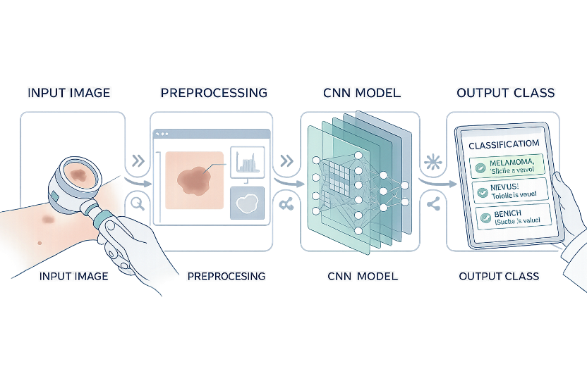

Fig 1.1: Skin Cancer Classification Process

CHAPTER 2: PROBLEM STATEMENT

2.1 Problem Definition
Skin cancer is one of the most commonly occurring cancers worldwide and has become a major public health concern. It is primarily caused due to the uncontrolled growth of abnormal skin cells, often triggered by excessive exposure to ultraviolet (UV) radiation. Early detection of skin cancer significantly improves treatment outcomes; however, identifying cancerous lesions at an early stage remains a challenging task.
Traditional diagnostic methods rely on dermatologists who visually examine skin lesions or use dermoscopic tools for detailed analysis. Although these methods are effective, they have several limitations. The accuracy of diagnosis depends heavily on the experience and expertise of the clinician. In many cases, especially in rural or resource-limited areas, access to experienced dermatologists is limited, leading to delayed diagnosis.
Another major issue is the variability in human interpretation. Different experts may provide different diagnoses for the same lesion, leading to inconsistency. Under heavy workload conditions, the chances of human error increase, which may result in incorrect classification of skin cancer types.
In addition, the growing number of patients creates a burden on healthcare systems, making it difficult to provide timely diagnosis for everyone. Manual analysis of dermoscopic images is time-consuming and requires careful observation of complex patterns, textures, and color variations, which may not always be accurately interpreted.
To overcome these challenges, there is a need for an automated and intelligent system that can assist in the classification of skin cancer. With the advancement of Artificial Intelligence and Deep Learning, computer-based models can now analyze medical images with high accuracy.
This project proposes a deep learning-based approach using Convolutional Neural Networks (CNN) and transfer learning techniques to classify skin cancer images into multiple categories. The system is designed to act as a decision-support tool for clinicians, helping them make faster, more consistent, and more accurate diagnoses.
The model is trained using the HAM10000 dataset, which contains a large number of labeled dermoscopic images across seven different skin disease classes. By leveraging this dataset and advanced deep learning techniques, the system aims to improve diagnostic efficiency and support early detection of skin cancer.
Thus, the proposed system aims to bridge the gap between medical expertise and technological advancement by providing an efficient AI-based diagnostic solution.

2.2 Objectives
The main objectives of this project are as follows:
- To develop an automated system for the classification of skin cancer using deep learning techniques
- To utilize dermoscopic image data for training and evaluating the model
- To implement a Convolutional Neural Network (CNN) using transfer learning with MobileNetV2
- To classify skin lesions into seven different categories accurately
- To perform data preprocessing techniques such as image resizing, normalization, and labeling
- To handle class imbalance in the dataset using techniques like data augmentation and class weighting
- To evaluate the performance of the model using accuracy and loss metrics
- To design a system that can assist dermatologists in making faster and more reliable decisions
- To reduce human effort and minimize diagnostic errors
- To provide a scalable solution that can be extended for real-time clinical applications

CHAPTER 3: LITERATURE REVIEW
3.1 Deep Learning in Skin Disease Classification
Classification of Skin Disease Based on Deep Learning
Zhang et al. (2021) presented a comprehensive review of deep learning techniques applied to skin disease classification, emphasizing their growing importance in dermatology due to limited medical resources and increasing patient demand. The study analyzed key components involved in automated diagnosis, including dataset availability, preprocessing methods, model architectures, and evaluation metrics. The authors discussed how convolutional neural networks (CNNs) have become the dominant approach due to their ability to automatically extract hierarchical features from skin lesion images. They also highlighted the role of image preprocessing techniques such as resizing, normalization, and augmentation in improving model performance. Furthermore, the study examined commonly used evaluation metrics, including accuracy, sensitivity, and specificity, to assess model effectiveness. A significant contribution of this work is the identification of critical steps in the diagnostic pipeline, such as image acquisition, feature extraction, classification, and validation. The authors concluded that deep learning models can achieve performance comparable to dermatologists in specific scenarios. However, they also pointed out challenges such as dataset imbalance, lack of interpretability, and the need for large annotated datasets for real-world implementation.

3.2 CNN-Based Feature Learning Approaches
Discriminative Feature Learning for Skin Disease Classification Using Deep CNN
Ahmad et al. (2020) proposed a deep convolutional neural network-based approach for discriminative feature learning in skin disease classification. The primary objective of the study was to enhance feature extraction by designing a model capable of capturing complex patterns in dermoscopic images. The authors emphasized that traditional machine learning techniques rely heavily on handcrafted features, which often limit performance and generalization. In contrast, their deep CNN model automatically learns discriminative features directly from raw images, leading to improved classification accuracy. The study utilized a large dataset of skin lesion images and applied various preprocessing techniques to improve image quality and consistency. Additionally, the model incorporated multiple convolutional and pooling layers to extract both low-level and high-level features. The results demonstrated that the proposed approach significantly outperformed conventional methods in terms of accuracy and robustness. The authors also highlighted the importance of proper training strategies and hyperparameter tuning in achieving optimal performance. Overall, the study reinforced the effectiveness of deep CNNs in medical image analysis and suggested their potential for real-time clinical applications.

3.3 Dermatologist-Level Classification Using Deep Learning
Dermatologist-level classification of skin cancer with deep neural networks
Esteva et al. (2017) conducted a groundbreaking study demonstrating that deep neural networks can achieve dermatologist-level performance in skin cancer classification. The researchers trained a deep convolutional neural network using a large dataset consisting of over 100,000 clinical images representing various skin conditions. The model was designed to classify skin lesions into different categories, including benign and malignant types. A key contribution of this study was the use of transfer learning, where a pre-trained network was fine-tuned on medical images to improve performance. The results showed that the model achieved accuracy comparable to experienced dermatologists, marking a significant milestone in medical artificial intelligence. The authors also conducted validation experiments by comparing the model’s predictions with those of professional dermatologists, further confirming its reliability. The study highlighted the potential of deep learning to assist in early diagnosis and reduce diagnostic errors. However, it also acknowledged limitations such as the need for diverse datasets and clinical validation. This research laid the foundation for future work in AI-based healthcare systems and demonstrated the practical applicability of deep learning in dermatology.

3.4 Comprehensive Review of Machine Learning Techniques
Innovative approaches for skin disease identification in machine learning
Vayadande et al. (2024) presented a comprehensive survey of machine learning and deep learning techniques used in skin disease identification. The study reviewed a wide range of approaches, including traditional machine learning algorithms such as support vector machines (SVM) and k-nearest neighbors (KNN), as well as advanced deep learning models like CNNs and hybrid architectures. The authors provided a comparative analysis of these methods based on performance, computational complexity, and applicability in real-world scenarios. The study emphasized that deep learning models generally outperform traditional techniques due to their ability to automatically learn features from data. Additionally, the authors discussed the role of ensemble methods, which combine multiple models to improve classification accuracy and robustness. The paper also highlighted challenges such as data scarcity, class imbalance, and variability in skin lesion appearance. Furthermore, it stressed the importance of high-quality datasets and standardized evaluation metrics for fair comparison of models. Overall, the study provided valuable insights into the evolution of skin disease classification techniques and suggested future research directions focusing on hybrid and explainable AI models.

3.5 CNN-Based Skin Disease Detection Systems
Skin Disease Detection Using CNN
Saranya et al. (2024) developed a convolutional neural network-based system for automated skin disease detection. The study aimed to design an efficient and accurate model capable of classifying multiple types of skin diseases using image data. The authors emphasized the importance of preprocessing steps such as image resizing, normalization, and noise reduction to ensure consistent input quality. The proposed CNN architecture consisted of multiple convolutional layers followed by pooling and fully connected layers, enabling the extraction of both low-level and high-level features. The model was trained on a dataset of skin images and evaluated using standard performance metrics such as accuracy and loss. The results demonstrated that the CNN-based system achieved high classification accuracy, indicating its effectiveness in medical image analysis. The study also highlighted the potential of such systems to assist dermatologists in early diagnosis and reduce workload. However, the authors noted limitations such as the need for larger datasets and improved generalization capabilities. The research concluded that CNN-based approaches are highly promising for real-time skin disease detection applications.

3.6 Enhanced CNN Architectures (DeepSkinNet)
DeepSkinNet: ReLU-Enhanced CNNs for Skin Disease Detection
Pandiarajan et al. (2024) introduced DeepSkinNet, an enhanced convolutional neural network architecture designed for accurate skin disease detection. The study focused on improving feature extraction by incorporating Rectified Linear Unit (ReLU) activation functions within the CNN layers. The authors argued that activation functions play a critical role in determining the performance of deep learning models. By using ReLU, the model was able to achieve faster convergence and improved accuracy compared to traditional activation functions. The architecture consisted of multiple convolutional, pooling, and fully connected layers, enabling effective learning of complex patterns in skin lesion images. The model was trained on a diverse dataset and evaluated using performance metrics such as accuracy and precision. The results demonstrated that DeepSkinNet outperformed several existing models, highlighting the importance of architectural optimization. The study also discussed the role of hyperparameter tuning and regularization techniques in preventing overfitting. Overall, the research provided valuable insights into designing efficient CNN architectures for medical image classification and emphasized the significance of activation function selection in deep learning.

3.7 Hybrid Deep Learning Models (MobileNetV2 + LSTM)
Classification of Skin Disease Using MobileNetV2 and LSTM
Srinivasu et al. (2021) proposed a hybrid deep learning model combining MobileNetV2 and Long Short-Term Memory (LSTM) networks for skin disease classification. The study aimed to leverage the strengths of both architectures, where MobileNetV2 was used for efficient feature extraction and LSTM for capturing sequential dependencies in the data. The authors highlighted that lightweight models like MobileNetV2 are suitable for deployment in resource-constrained environments such as mobile devices. The dataset used in the study consisted of labeled skin images, and preprocessing techniques were applied to improve data quality. The hybrid model demonstrated improved classification accuracy compared to standalone CNN models. The use of LSTM allowed the system to capture temporal or contextual relationships, enhancing feature representation. The study also emphasized the importance of transfer learning and fine-tuning in achieving optimal performance. Despite its advantages, the model faced challenges such as increased computational complexity and the need for careful parameter tuning. Overall, the research demonstrated the potential of hybrid models in improving the accuracy and efficiency of skin disease classification systems.

3.8 Transfer Learning-Based Approaches
Skin Cancer Classification Using CNN with Transfer Learning
Ali et al. (2021) explored the use of transfer learning techniques for skin cancer classification using deep convolutional neural networks. The study focused on overcoming the challenge of limited labeled data by utilizing pre-trained models such as VGG and ResNet. These models were initially trained on large-scale datasets and then fine-tuned for the specific task of skin disease classification. The authors demonstrated that transfer learning significantly reduces training time while improving model accuracy. The preprocessing stage included image resizing, normalization, and augmentation to enhance dataset diversity. The results showed that the fine-tuned models achieved high classification performance, outperforming models trained from scratch. The study also highlighted the importance of selecting appropriate pre-trained architectures and tuning hyperparameters to achieve optimal results. Additionally, the authors discussed the potential of transfer learning in real-world applications, particularly in scenarios with limited data availability. However, challenges such as domain adaptation and model generalization were also identified. Overall, the research confirmed that transfer learning is a powerful and practical approach in medical image classification.

3.9 Recent Review of State-of-the-Art Models
State-of-the-art skin disease classification review
Jaiyeoba et al. (2025) presented a detailed review of state-of-the-art deep learning models for skin disease classification. The study analyzed recent advancements in neural network architectures, including CNNs, transformers, and hybrid models. The authors provided a comprehensive comparison of various approaches based on accuracy, computational efficiency, and scalability. The paper emphasized the growing importance of large annotated datasets and advanced preprocessing techniques in improving model performance. Additionally, it discussed the role of explainable artificial intelligence (XAI) in enhancing the interpretability of deep learning models, which is crucial for clinical adoption. The study also highlighted emerging trends such as the integration of multimodal data and the use of attention mechanisms to improve feature extraction. Despite significant progress, the authors identified several challenges, including data imbalance, lack of standardization, and limited real-world validation. The review concluded that while deep learning has achieved remarkable success in skin disease classification, further research is needed to address these challenges and ensure reliable deployment in clinical settings.

3.10 Ensemble and Wavelet-Based CNN Models
Skin cancer classification using CNN ensembles and Gabor wavelets
Attallah (2024) proposed an advanced approach for skin cancer classification using multi-directional CNN ensembles combined with Gabor wavelet-based feature extraction. The study aimed to improve classification accuracy by integrating multiple models and capturing texture-based features of skin lesions. Gabor wavelets were used to extract directional and frequency-based information, which is particularly useful for analyzing complex patterns in medical images. The ensemble of CNN models allowed the system to combine predictions from multiple networks, resulting in improved robustness and generalization. The model was evaluated on a dataset of skin images and demonstrated superior performance compared to single-model approaches. The study also highlighted the importance of combining traditional image processing techniques with modern deep learning methods to achieve better results. However, the approach increased computational complexity and required significant resources for training. Despite these limitations, the research demonstrated the effectiveness of ensemble learning and feature engineering in enhancing skin disease classification systems and provided a promising direction for future work.

CHAPTER 4: RESEARCH METHODOLOGY

4.1 Methodology Framework
The proposed system adopts a systematic methodology for the classification of skin cancer using deep learning techniques. The methodology is designed to ensure efficient processing of medical images and accurate prediction of skin disease categories.
The overall workflow begins with the collection of dermoscopic images from the dataset. These images are then subjected to preprocessing to ensure consistency in size, format, and quality. Preprocessing is a crucial step as raw medical images often contain noise, variations in lighting, and inconsistencies that may affect model performance.
After preprocessing, the images are passed through a deep learning model based on a Convolutional Neural Network (CNN). The model extracts important visual features such as edges, textures, shapes, and color patterns that are essential for distinguishing between different types of skin lesions.
The extracted features are then analyzed using fully connected layers, which perform classification by mapping features to predefined classes. The final output is generated in the form of a predicted class label along with a confidence score, which indicates the reliability of the prediction.
The methodology is designed to be efficient, scalable, and adaptable for future improvements. It ensures smooth data flow from input to output and minimizes manual intervention.

4.2 Data Collection
The dataset used in this research is the HAM10000 (Human Against Machine with 10,000 training images) dataset. It is a widely used benchmark dataset in the field of medical image analysis and skin cancer classification.
The dataset consists of 10,015 dermoscopic images, which are categorized into seven distinct classes of skin diseases. These classes include:
- Actinic keratoses (akiec)
- Basal cell carcinoma (bcc)
- Benign keratosis-like lesions (bkl)
- Dermatofibroma (df)
- Melanoma (mel)
- Melanocytic nevi (nv)
- Vascular lesions (vasc)
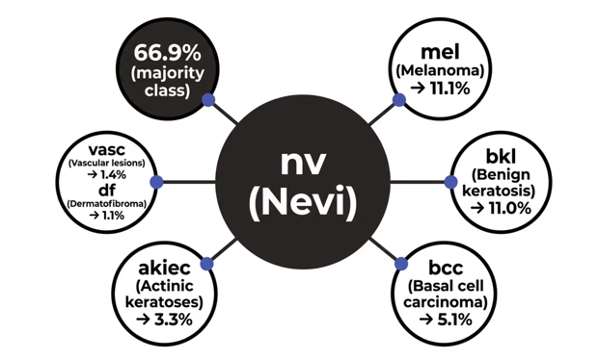

Fig 4.1: Dataset Description

Each image in the dataset is accompanied by metadata such as patient age, gender, and anatomical location of the lesion. This additional information helps in understanding the dataset distribution and analyzing patterns.
The dataset is collected from multiple sources and clinical environments, ensuring diversity in terms of image quality and patient demographics. This diversity makes the dataset suitable for training robust machine learning models.
However, one of the major challenges associated with the dataset is class imbalance. The melanocytic nevi (nv) class dominates the dataset, accounting for more than 66% of the total samples, while other classes such as dermatofibroma and vascular lesions have significantly fewer samples.
To address this issue, preprocessing techniques such as data augmentation and class weighting are applied during model training. These techniques help in improving model performance for minority classes.
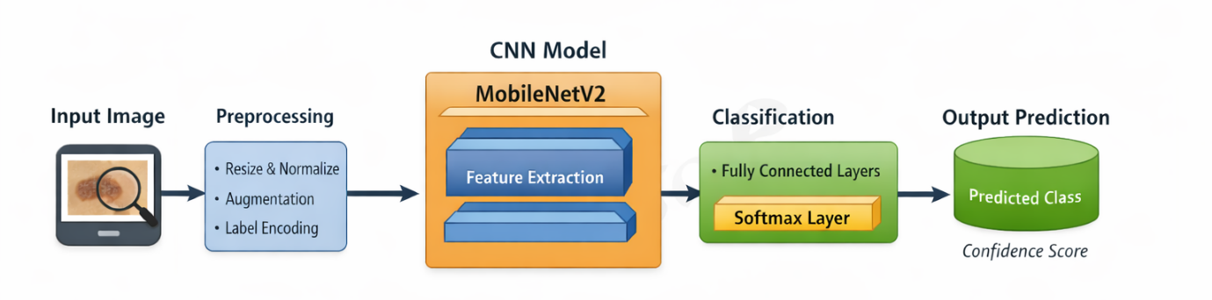

Fig 4.2: System Architecture of Skin Cancer Classification

4.3 Tools and Technologies Used
The development and implementation of the system are carried out using a combination of programming tools and machine learning frameworks.
- Programming Language: Python
Python is chosen due to its simplicity, readability, and extensive support for machine learning libraries.
- Deep Learning Libraries: TensorFlow and Keras
These libraries provide high-level APIs for building and training deep learning models efficiently.
- Data Handling Libraries: NumPy and Pandas
These libraries are used for numerical computations and data manipulation.
- Visualization Tool: Matplotlib
Matplotlib is used to generate graphs and visualize data distribution.
- Development Platform: Jupyter Notebook
Jupyter Notebook provides an interactive environment for writing and executing code, making it suitable for experimentation and analysis.
- Model Used: MobileNetV2
A pre-trained Convolutional Neural Network model that is efficient and suitable for image classification tasks.
These tools collectively provide a robust environment for developing the proposed system.
Table 4.1: Tools and Technologies Used
Category | Technology Used
Programming Language | Python
Libraries | TensorFlow, Keras
Data Handling | Numpy, Pandas
Visualization | Matplotlib
Platform | Jupyter Notebook
Model | MobileNetV2 (CNN)
Dataset | HAM10000

4.4 System Components
The system is divided into several components, each responsible for performing a specific function. This modular structure improves clarity, maintainability, and scalability of the system.
4.4.1 Input Component
The input component is responsible for acquiring dermoscopic images from the user or dataset. The input image serves as the starting point of the system and is passed to the preprocessing stage.
4.4.2 Preprocessing Component
The preprocessing component plays a vital role in preparing the input data for the deep learning model. Since the dataset consists of images of varying sizes and qualities, preprocessing ensures uniformity.
The key preprocessing steps include:
- Resizing images to a fixed dimension suitable for the model
- Normalizing pixel values to improve training efficiency
- Converting images into numerical arrays
- Applying data augmentation techniques such as rotation, flipping, and zooming
These steps help in improving model accuracy and reducing overfitting.

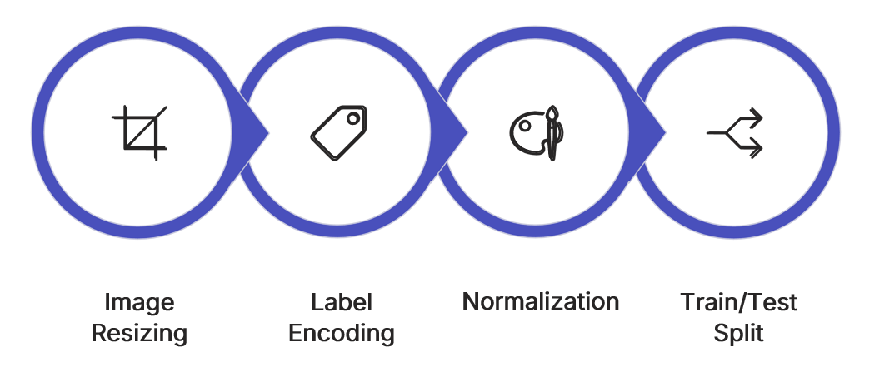

Fig 4.3: Data Preprocessing Pipeline

4.4.3 Model Component
The model component is the core of the system, where feature extraction takes place. A Convolutional Neural Network (CNN) is used to learn complex patterns from the images.
The model analyzes the input images and extracts important features such as texture, edges, and shapes. These features are essential for distinguishing between different skin diseases.

4.4.4 Classification Component
The classification component uses the features extracted by the model to classify the input image into one of the predefined categories. This is achieved using fully connected layers followed by a softmax function.
The softmax layer produces probability values for each class, and the class with the highest probability is selected as the final prediction.

4.4.5 Output Component
The output component displays the final result to the user. The output includes the predicted class label and the corresponding confidence score. This helps in understanding the reliability of the prediction.

Component | Description
Input | Accepts skin image
Preprocessing | Resizing, normalization
Model | CNN (MobileNetV2)
Classification | Predicts Disease Class
Output | Display result with confidence
Table 4.2: Description of System Components

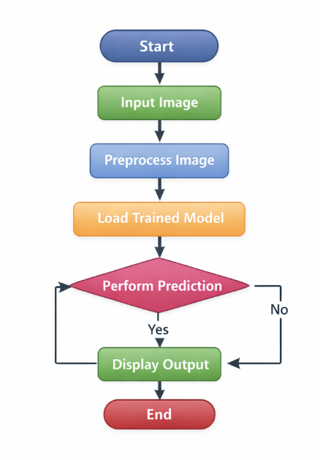

Fig 4.4: Flowchart of System Working

4.5 Model Architecture
The model architecture used in this project is based on MobileNetV2, which is a lightweight and efficient deep learning architecture. It is specifically designed for mobile and embedded vision applications and provides high accuracy with reduced computational cost.
MobileNetV2 uses depthwise separable convolutions, which significantly reduce the number of parameters and computational complexity compared to traditional CNN models.
The architecture consists of the following layers:
- MobileNetV2 Base Layer:
This layer extracts features from the input image using convolution operations. It captures important visual patterns required for classification.
- Global Average Pooling Layer:
This layer reduces the dimensionality of feature maps and converts them into a single vector.
- Dense Layer:
The dense layer processes the extracted features and prepares them for classification.
- Dropout Layer:
Dropout is used to prevent overfitting by randomly deactivating neurons during training.
- Softmax Layer:
This is the final layer, which outputs probability values for each class.
Transfer learning is applied by using pre-trained weights from the ImageNet dataset. Initially, the base layers of the model are frozen, and only the custom layers are trained. Later, fine-tuning is performed by unfreezing some layers to improve performance.
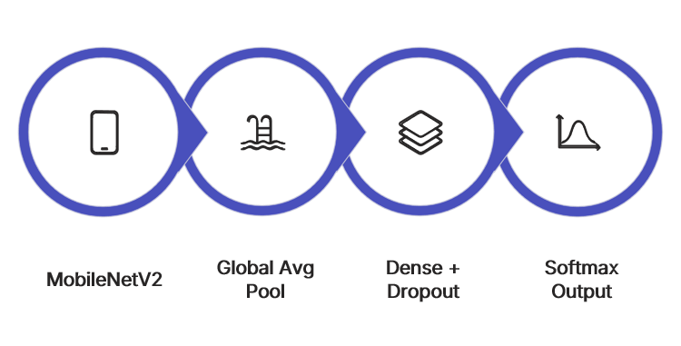Fig 4.5: MobileNetV2 Model Architecture

4.6 Data Flow Representation
The data flow representation describes how data moves through different stages of the system.
The process begins with the input image, which is passed to the preprocessing component. The preprocessed image is then fed into the deep learning model, where feature extraction is performed.
The extracted features are passed to the classification component, which determines the category of the image. Finally, the output is displayed in the form of a predicted class label and confidence score.
This structured flow ensures that the system operates efficiently and produces accurate results.
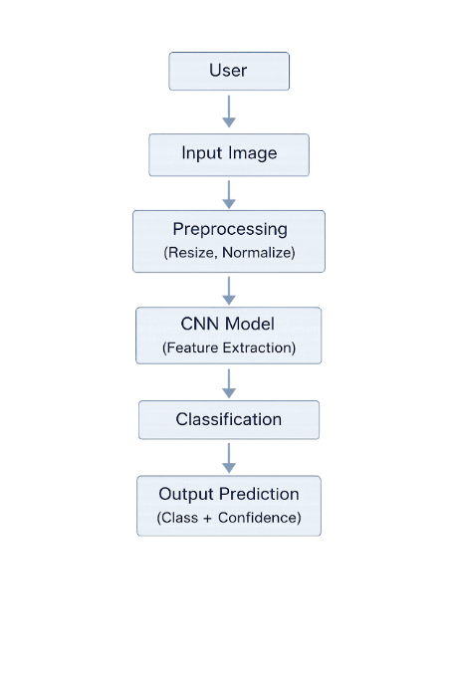

Fig 4.6: Data Flow Diagram of the System
4.7 Methodological Considerations
Several important considerations are taken into account while designing the methodology:
- Handling Class Imbalance:
Data augmentation and class weighting are used to improve model performance for minority classes.
- Avoiding Overfitting:
Techniques such as dropout, validation, and data augmentation are applied.
- Efficiency:
MobileNetV2 is chosen due to its lightweight architecture and faster computation.
- Scalability:
The system can be extended for real-time applications and integration with healthcare systems.
- Reliability:
The system is designed to produce consistent and accurate predictions.
These considerations ensure that the methodology is robust and suitable for practical applications.

“The proposed methodology provides an efficient and scalable approach for accurate skin cancer classification using deep learning techniques.”
CHAPTER 5: ANALYSIS AND RESEARCH IMPLEMENTATION
5.1 Data Presentation
Data presentation is an important step in understanding the structure, distribution, and characteristics of the dataset used in this study. The dataset used is the HAM10000 dataset, which contains dermoscopic images categorized into seven different classes of skin diseases.
To analyze the dataset effectively, graphical representations are used. These visualizations help in identifying patterns, imbalances, and trends that directly influence the performance of the deep learning model.

5.1.1 Class Distribution Analysis
The dataset consists of seven different classes of skin diseases. However, the distribution of images across these classes is not uniform. It is observed that the melanocytic nevi (nv) class dominates the dataset, contributing more than 66% of the total images.
This imbalance can lead to biased predictions, where the model performs well on majority classes but struggles with minority classes such as melanoma (mel) and dermatofibroma (df). Therefore, it becomes necessary to apply techniques such as data augmentation and class weighting to improve model performance.
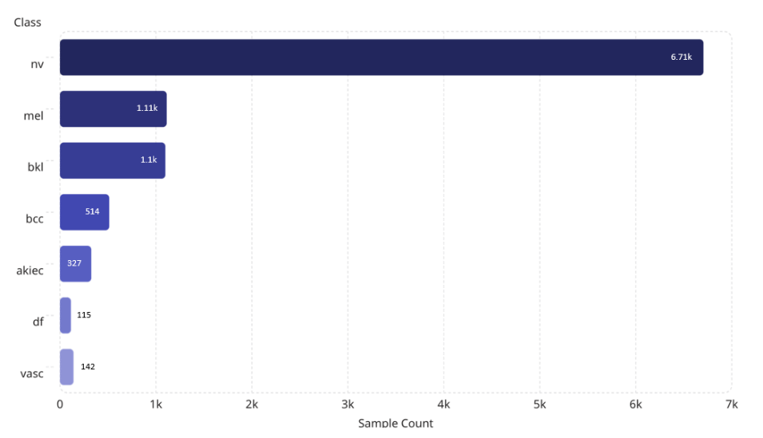
Fig 5.1: Distribution of Skin Disease Classes

Table 5.1: Skin Disease Classes in HAM10000 Dataset

S.no | Disease Name | Code
1 | Actinic Keratoses | akiec
2 | Basal cell carcinoma | bcc
3 | Benign keratosis-like lesions | bkl
4 | Dermatofibroma | df
5 | Melanoma | mel
6 | Melanocytic nevi | nv
7 | Vascular lesions | vasc
5.1.2 Distribution Based on Body Part
The dataset also includes information about the anatomical location of skin lesions. Analysis shows that most of the images are collected from body parts such as the back, trunk, and lower extremities.
On the other hand, regions like the face, scalp, and neck have fewer samples. This uneven distribution may affect the model’s ability to generalize across all body regions.

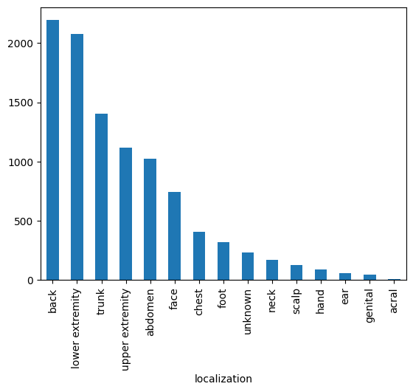

Fig 5.2: Distribution of Lesions by Body Part

5.1.3 Age Distribution Analysis
The dataset contains patient age information, which helps in understanding demographic trends. It is observed that the majority of samples belong to individuals in the 40–60 years age group, indicating a higher occurrence of skin diseases in older individuals.
Younger age groups are underrepresented, which may limit the model’s performance for those categories.
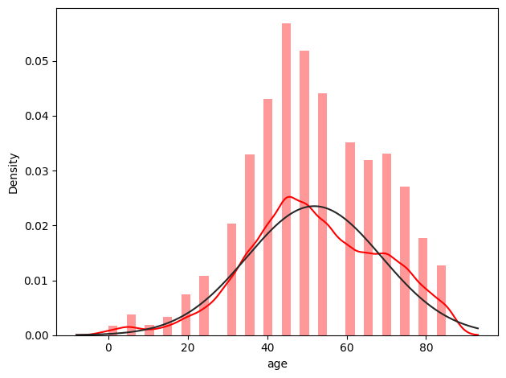

Fig 5.3: Distribution of Patients by Age

5.1.4 Summary of Data Insights
The analysis of dataset distribution highlights several key challenges, including class imbalance and uneven distribution across body parts and age groups. These challenges can affect model performance if not properly addressed.
To overcome these issues, preprocessing techniques such as data augmentation, normalization, and class weighting are applied during implementation.

5.2 Implementation of the Work
The implementation of the proposed system involves several stages, including data preprocessing, model development, training, and prediction. Each stage is carefully designed to ensure efficient processing and accurate classification of skin lesions.
5.2.1 Data Preprocessing
Data preprocessing is the first and most critical step in the implementation process. The raw dermoscopic images in the dataset vary in size, resolution, and quality. Therefore, preprocessing is required to standardize the input data and ensure consistency across all samples.
The preprocessing steps include:
• Image Resizing:
All images are resized to a fixed dimension suitable for the model. This ensures uniform input size.
• Normalization:
Pixel values are scaled to a range between 0 and 1, which improves training efficiency and model convergence.
• Label Encoding:
The categorical labels are converted into numerical format for model training.
• Data Augmentation:
Techniques such as rotation, flipping, zooming, and shifting are applied to artificially increase the size of the dataset. This helps in handling class imbalance and improving generalization.
These preprocessing steps ensure that the dataset is clean, consistent, and suitable for deep learning, ultimately enhancing model accuracy, robustness, and overall performance during training and evaluation phases.

5.2.2 Model Development
The model used in this project is based on MobileNetV2, a pre-trained Convolutional Neural Network. It is selected due to its lightweight architecture and high efficiency in image classification tasks.
The model is developed using transfer learning, where a pre-trained network is adapted to a new task. MobileNetV2 is initially trained on the ImageNet dataset, which contains millions of images across various categories. This allows the model to learn general image features such as edges, textures, and patterns.
In this implementation, the base layers of MobileNetV2 are used as a feature extractor. Custom layers are added on top of the base model to perform classification specific to skin disease categories.
The added layers include:
- Global Average Pooling Layer
- Dense (Fully Connected) Layers
- Dropout Layer
- Softmax Output Layer
These layers enable the model to classify images into the seven predefined categories.

5.2.3 Model Training
The model is trained using the processed dataset over multiple epochs. During training, the model learns to identify patterns and relationships between input images and their corresponding labels.
Key training parameters include:
- Optimizer: Adam
- Loss Function: Categorical Cross-Entropy
- Epochs: 50
- Batch Size: 16
The training process is monitored using metrics such as accuracy and loss. Validation data is used to evaluate model performance during training and to prevent overfitting.
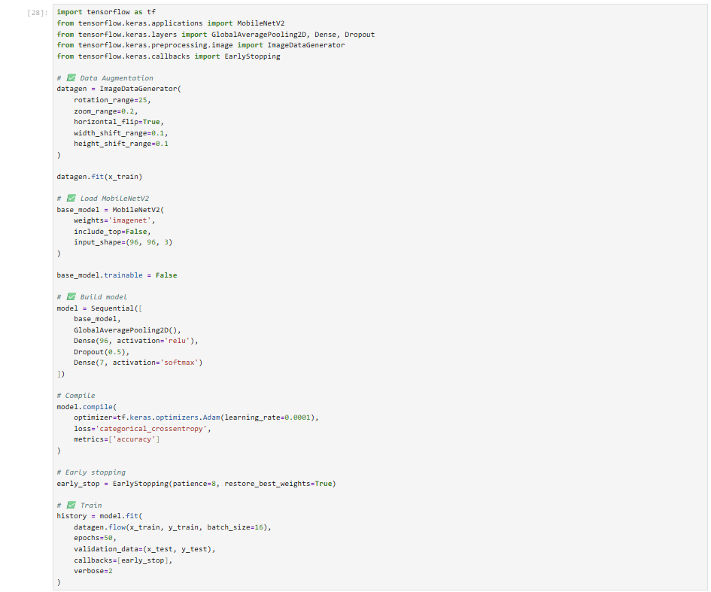
Fig 5.4: Model Training Code

Parameter | Value
Epochs before fine tuning | 50
Epochs After fine tuning | 30
Batch Size | 16
Optimizer | Adam
Loss Function | Categorical Cross-Entropy
Learning Rate | 0.00001
Table 5.2: Training Parameters

5.2.4 Transfer Learning and Fine-Tuning
Transfer learning is a key component of this project. Instead of training a model from scratch, a pre-trained model is used to leverage existing knowledge and previously learned feature representations from large-scale datasets.
Initially, the convolutional base of MobileNetV2 is frozen, meaning that its weights are not updated during training. This helps in preserving the features learned from the ImageNet dataset and reduces computational cost while preventing overfitting in early stages.
After training the top layers, fine-tuning is performed by unfreezing some of the deeper layers of the model. This allows the model to adapt its learned features specifically to the skin lesion dataset and capture more domain-specific patterns.
A lower learning rate is used during fine-tuning to prevent drastic changes in the pre-trained weights. This ensures stable training, gradual updates, and better generalization across unseen data samples.
Transfer learning significantly improves model performance, especially when the dataset is limited and imbalanced. It reduces training time, enhances feature extraction capability, and enables efficient learning even with fewer labeled examples.

Table 5.3: Model Performance Before and After Fine-Tuning
Model Stage | Training Accuracy | Validation Accuracy | Remarks
Without Fine-Tuning (Frozen Layers) | 0.6686 | 0.6023 | Model uses pre-trained features only
With Fine-Tuning (Unfrozen Layers) | 0.7364 | 0.6857 | Model adapts to skin lesion dataset
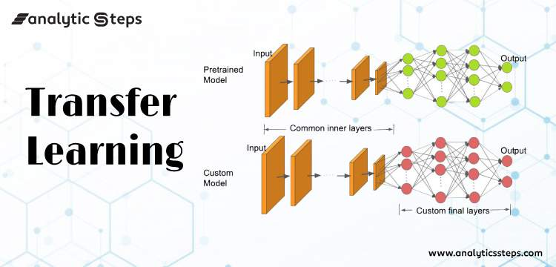
Fig 5.5: Transfer Learning and Fine-Tuning Process

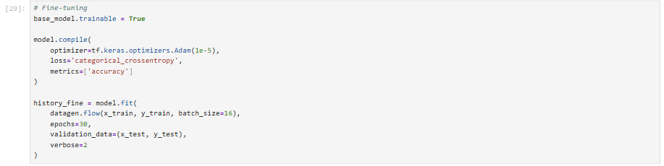
Fig 5.6: Fine Tuning Code
5.2.5 Prediction and Output
Once the model is trained, it is used to predict the class of new input images. The output is generated in the form of probability values for each class.
The class with the highest probability is selected as the predicted class. The system also displays a confidence score, which indicates how certain the model is about its prediction.
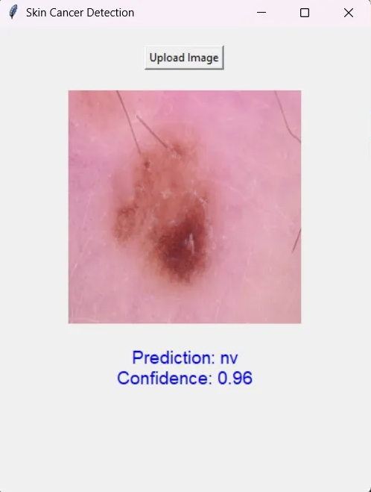

Fig 5.7: Graphical User Interface of the Skin Cancer Classification System
5.3 Analysis and Interpretation
The analysis of the proposed system focuses on evaluating its performance and understanding the factors that influence its accuracy.
One of the major challenges observed is the class imbalance in the dataset. The dominance of the melanocytic nevi (nv) class leads to biased predictions. However, the use of data augmentation and class weighting helps in reducing this bias and improving performance across all classes.
Transfer learning plays a significant role in enhancing model accuracy. By using a pre-trained model, the system is able to extract meaningful features even with limited data. Fine-tuning further improves performance by adapting the model to domain-specific patterns.
The model demonstrates good generalization capability, as it performs well on both training and validation data. However, certain limitations remain due to uneven data distribution and variability in image quality.
The results indicate that the proposed system is capable of accurately classifying skin cancer images and can serve as a reliable decision-support tool for medical professionals.
Overall, the implementation and analysis confirm that deep learning techniques, combined with transfer learning, provide an effective solution for skin cancer classification.

CHAPTER 6: RESULTS AND DISCUSSION

6.1 Introduction
This chapter presents the results obtained from the implementation of the proposed skin cancer classification system. It includes evaluation of model performance, analysis of training behavior, and discussion of key findings.
The results are analyzed using performance metrics such as accuracy and loss. Graphical representations are used to understand how the model performs during training and validation. Additionally, trends observed in the graphs help identify overfitting, underfitting, and overall model stability during different training epochs, enabling better understanding of model learning behavior and assisting in making necessary improvements to the model.

6.2 Model Performance Evaluation
The performance of the model is evaluated using training and validation datasets. The key metrics used for evaluation include accuracy and loss.
Accuracy measures how correctly the model classifies the images, while loss indicates how well the model fits the data.
The model achieves satisfactory performance, demonstrating its ability to classify skin lesion images effectively. The use of transfer learning and fine-tuning contributes significantly to improving accuracy. Furthermore, consistent validation results indicate that the model generalizes well to unseen data, ensuring reliable and robust prediction performance in practical real-world medical diagnostic scenarios across diverse datasets and varying imaging conditions.

6.3 Training and Validation Analysis
The training process is analyzed using accuracy and loss curves plotted over multiple epochs.
The training accuracy gradually increases as the number of epochs increases, indicating that the model is learning from the dataset. At the same time, the training loss decreases, showing improved model performance.
Similarly, validation accuracy also increases, while validation loss decreases. This indicates that the model is able to generalize well to unseen data.
The gap between training and validation accuracy is minimal, which suggests that the model does not suffer from significant overfitting.
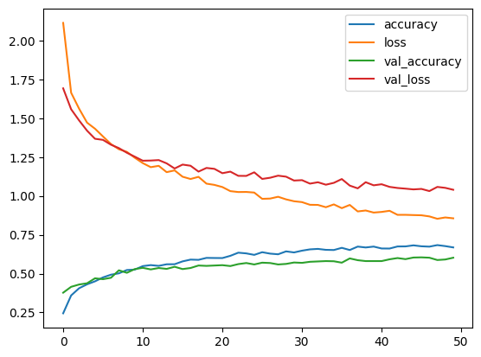

Fig 6.1: Training and Validation Accuracy and Loss

6.4 Results Visualization
The graphical representation of model performance provides a clear understanding of learning behavior.
The accuracy graph shows a steady increase in both training and validation accuracy, indicating effective learning. The loss graph shows a decreasing trend, confirming that the model is optimizing correctly.
These results demonstrate that the model is stable and performs well across different stages of training.

Table 6.1: Model Performance Metrics
Metric | Value (%)
Training Accuracy | 0.73
Validation Accuracy | 0.68
Training Loss | 0.74
Validation Loss | 0.82

6.5 Discussion of Results
The results indicate that the proposed system is capable of accurately classifying skin cancer images. The use of MobileNetV2 with transfer learning significantly improves performance.
The model successfully learns important features such as texture, color variations, and patterns present in skin lesions. This enables it to distinguish between different classes effectively.
However, certain limitations are observed due to class imbalance in the dataset. The model may show slightly lower performance for minority classes such as melanoma and dermatofibroma.
Despite these challenges, the use of data augmentation and fine-tuning helps in improving performance.
Overall, the system demonstrates strong potential as a decision-support tool for early detection of skin cancer.

6.6 Key Findings
The following key findings are observed from the study:
- The use of transfer learning significantly improves model accuracy
- Fine-tuning enhances feature extraction and classification performance
- Data augmentation helps in handling class imbalance
- The model shows good generalization ability
- The system can assist medical professionals in diagnosis

6.7 Summary
This chapter presented the results and analysis of the proposed system. The model demonstrates good performance in classifying skin cancer images.
The use of deep learning techniques, combined with transfer learning, ensures efficient and accurate prediction. The findings highlight the effectiveness of the system and its potential for real-world applications.

CHAPTER 7: SUMMARY AND CONCLUSION

This project presents a deep learning-based approach for the classification of skin cancer using dermoscopic images. A Convolutional Neural Network (CNN) with MobileNetV2 as the base model is utilized along with transfer learning to enhance performance and efficiency. The study begins by addressing the challenges associated with traditional skin cancer diagnosis methods, which are often time-consuming and dependent on expert knowledge.
A detailed literature review was conducted to analyze existing techniques and advancements in medical image classification. The dataset used for this project is the HAM10000 dataset, which contains multiple classes of skin lesions. Exploratory Data Analysis (EDA) was performed to understand key characteristics such as class imbalance and distribution patterns.
The methodology involves preprocessing steps including image resizing, normalization, label encoding, and data augmentation. These steps ensure data consistency and help improve model generalization. The implementation phase focuses on model training using transfer learning, where MobileNetV2 is initially used as a feature extractor and later fine-tuned to adapt to the specific dataset.
The model is evaluated using performance metrics such as accuracy and loss. The results indicate that the proposed system achieves satisfactory accuracy and demonstrates strong capability in classifying skin lesion images. Transfer learning significantly reduces training time while improving overall performance.
In conclusion, the developed system provides an efficient and scalable solution for automated skin cancer classification. Despite challenges such as class imbalance and data variability, the model performs effectively. This system can assist medical professionals in early detection and diagnosis, highlighting the growing importance of artificial intelligence in healthcare applications.

CHAPTER 8: LIMITATIONS AND FUTURE WORK

8.1 Limitations
Although the proposed system achieves good performance in classifying skin cancer images, there are certain limitations that need to be considered.
One of the major limitations is the class imbalance present in the dataset. The melanocytic nevi (nv) class dominates the dataset, which may lead to biased predictions and reduced accuracy for minority classes such as melanoma and dermatofibroma.
Another limitation is the limited dataset size. Although the HAM10000 dataset is widely used, it may not fully represent the diversity of real-world skin conditions. Variations in lighting, image quality, and skin tone may affect the model’s performance.
The model is also dependent on image quality. Poor-quality or blurred images may lead to incorrect predictions. Additionally, the system does not incorporate clinical data such as patient history, which could improve diagnostic accuracy.
Furthermore, the system is designed for research purposes and is not yet optimized for real-time clinical use. It requires further validation and testing before deployment in healthcare environments.

8.2 Future Work
There are several opportunities to improve and extend the proposed system in the future.
One potential improvement is to address the issue of class imbalance by using advanced techniques such as synthetic data generation or more balanced datasets. This would help improve model performance across all classes.
The dataset can be expanded by including more images from diverse sources, which would enhance the model’s ability to generalize to real-world scenarios.
Another area of improvement is the use of more advanced deep learning architectures such as EfficientNet or hybrid models, which may provide better accuracy and efficiency.
The system can also be extended to include real-time image analysis using mobile or web applications. This would make the system more accessible and useful in practical scenarios.
Incorporating additional clinical data such as patient history, symptoms, and metadata can further improve the accuracy and reliability of predictions.
Finally, the model can be deployed as a decision-support system for dermatologists, assisting in early diagnosis and reducing workload.
BIBLIOGRAPHY
- Andre Esteva et al., “Dermatologist-level classification of skin cancer with deep neural networks,” Nature, 2017.
- Philipp Tschandl et al., “The HAM10000 Dataset: A Large Collection of Multi-Source Dermatoscopic Images of Common Pigmented Skin Lesions,” Scientific Data, 2018.
- Mark Sandler et al., “MobileNetV2: Inverted Residuals and Linear Bottlenecks,” IEEE CVPR, 2018.
- Kaiming He et al., “Deep Residual Learning for Image Recognition,” IEEE CVPR, 2016.
- Karen Simonyan and Andrew Zisserman, “Very Deep Convolutional Networks for Large-Scale Image Recognition,” ICLR, 2015.
- Geoffrey Hinton et al., “ImageNet Classification with Deep Convolutional Neural Networks,” NIPS, 2012.
- Alex Krizhevsky et al., “ImageNet Classification with Deep Convolutional Neural Networks,” NIPS, 2012.
- Gustavo Carneiro et al., “Deep Learning and Structured Prediction for the Segmentation of Mass in Mammograms,” MICCAI, 2015.
- Noel Codella et al., “Skin Lesion Analysis Toward Melanoma Detection: A Challenge at ISIC 2017,” ISBI, 2018.
- Nasr-Esfahani et al., “Melanoma Detection by Analysis of Clinical Images Using Convolutional Neural Network,” IEEE, 2016.
- Brinker et al., “Comparing Artificial Intelligence Algorithms to 157 German Dermatologists,” Annals of Oncology, 2019.
- Haenssle et al., “Man against Machine: Diagnostic Performance of a Deep Learning Convolutional Neural Network for Dermoscopic Melanoma Recognition,” Annals of Oncology, 2018.
- Codella et al., “Deep Learning Ensembles for Melanoma Recognition,” IBM Journal of Research, 2016.
- TensorFlow Documentation, Available: https://www.tensorflow.org
- Keras Documentation, Available: https://keras.io
- NumPy Documentation, Available: https://numpy.org
- Pandas Documentation, Available: https://pandas.pydata.org
- Matplotlib Documentation, Available: https://matplotlib.org
- International Skin Imaging Collaboration Archive: https://www.isic-archive.com
- Ian Goodfellow et al., Deep Learning, MIT Press, 2016.
- François Chollet, Deep Learning with Python, Manning Publications, 2017.
- Additional research articles and online resources related to deep learning and medical image analysis.

